 | 26.7 Editors - Properties Editor - Collection Properties Tab
Table of content
Collection Properties Tab 2
Visibility Panel 2
Selectable 2
Show in Renders 2
View Layer sub panel 2
Include 2
Holdout 2
Indirect Only 3
Instancing panel 3
Instance Offset 3
Instance offset menu 3
Set Offset from cursor 3
Set Offset from Object 3
Set Cursor to Offset 3
Exporters panel 3
Add 3
Export All 4
Exporter Operators 4
Line Art Panel 4
Usage 4
Include 4
Occlusion Only 4
Exclude 4
Intersection only 4
No Intersection 5
Collection Mask 5
Masks 5
Intersection Priority 5
Priority Value 5

Collection Properties Tab
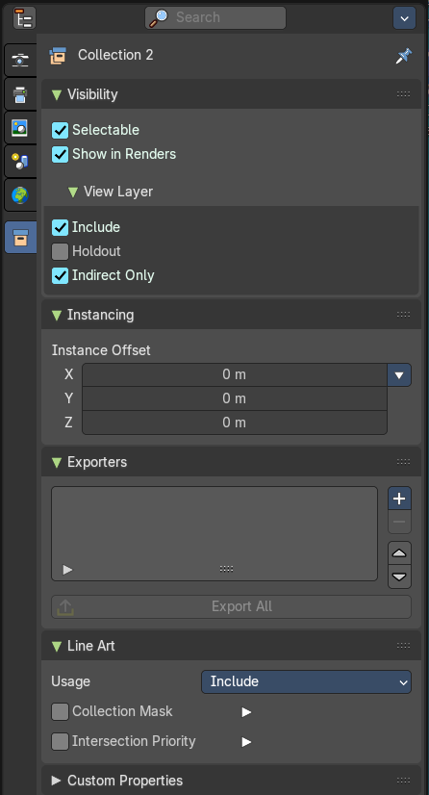
The collection tab provides you with collection related settings.

Visibility Panel
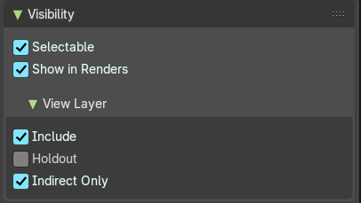
Set restrictions for the selected collection(s).

Selectable
Make this collection and its content selectable.

Show in Renders
Render the content of the collection.

View Layer sub panel

Include
Include the collection in the scene.

Holdout
Mask out objects in collection from view layer.

Indirect Only
Make the objects in the collection just contribute indirectly. By light or shadow or reflections.

Instancing panel

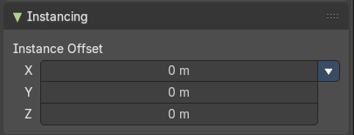
Instance Offset
Adjust an offset from the origin when instancing the collection.

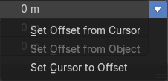
Instance offset menu

Set Offset from cursor
Set the offset used for collection instance based on cursor position.

Set Offset from Object
Set the offset used for collection instance based on the active object position.

Set Cursor to Offset
Set cursor position to the offset used for collection instances.

Exporters panel
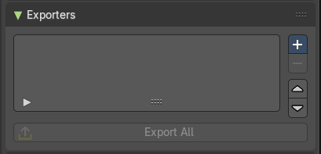
This panel contains the collection settings to assign an exporter per collection, where you can batch export collections in multiple file formats.
Collections where an exporter is added to shows the export symbol in the outliner.
Note: You can also batch export collections from the Topbar File header menu.
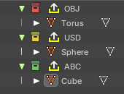
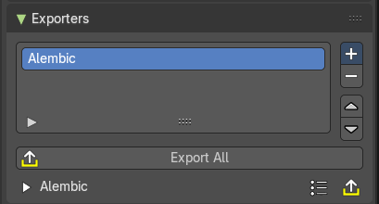

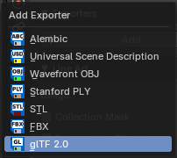
Add
Adds an exporter operator to the collection. This will show an exporter icon on the collection in the outliner, and list the file format the collection will export to.
File Exporter Types:
- Alembic
- USD (Universal Scene Description)
- OBJ (Wavefront Object)
- Stanford PLY
- FBX
- glTF 2.0

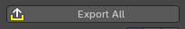
Export All
Exports all the collections with exporter operators assigned.

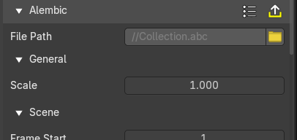
Exporter Operators
These settings comes from the chosen exporter. See chapter export in the File menu.

Line Art Panel
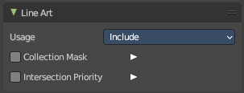

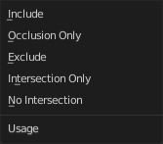
Usage
The method to display the line art in this collection.

Include
Generate feature lines for this collection.

Occlusion Only
Only use the collection to produce occlusion.

Exclude
Don't use this collection in line art.

Intersection only
Only generate intersection lines for this collection

No Intersection
Include this collection but do not generate intersection lines.

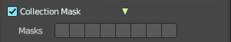
Collection Mask
Use custom intersection masks for faces in this colllection.

Masks
You can use up to 8 masks, starting with value 0.

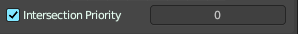
Intersection Priority
Assign intersection priority value for this collection.

Priority Value
The intersection line will be included into the object with the higher intersection priority value.

